<http://automationpractice.com/>

Test Case 1-

1- Open Applicaton

2- Verify correct site is opened

3- Click “Contact Us”

4- Select “Customer Service” from Subject heading

5- Enter valid email address and add some message and click send

6- Verify Success Message



Test Case 2-

1- Open Applicaton

2- Verify correct site is opened

3- Click “Contact Us”

4- Select “Customer Service” from Subject heading

5- Enter invalid email address and click send

6- Verify the error message

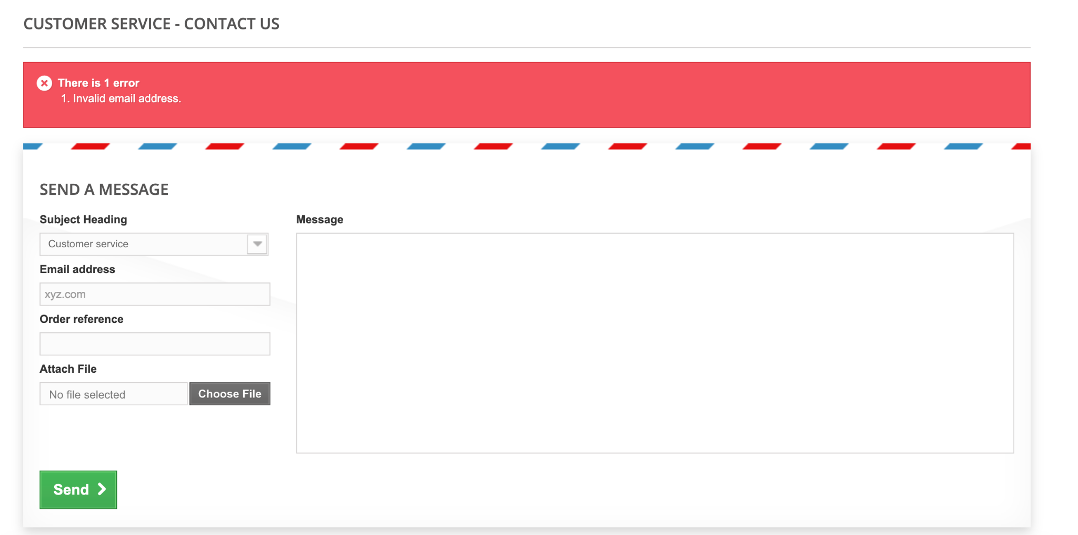

Test Case 3-

1- Open Applicaton

2- Click on Dresses | Casual Dresses

3- Select one Item from Result and add to cart

4- Open the cart and verify the same item added in cart and price is correct

